**2SD3 Assignment 1**

Rochan Muralitharan – muralr3

1. Diagram

   Description automatically generatedText

   Description automatically generated
2. a)

P1 = A

A = (a -> B | a -> D)

B = (b -> C | c -> D)

C = (a -> D | b -> A | d -> C)

D = (d -> A)

P2 = A

A = (b -> B | b -> C)

B = (b -> E | d -> D)

C = (c -> B)

D = (a -> A | b -> E | d -> C)

E = (a -> A | c -> C)

P3 = A

A = (a -> D| b -> B)

B = (a -> A | a -> C)

C = (b -> B | b -> D | c -> C)

D = (a -> C | c -> A)

b)

1. In Java File
2. Graphical user interface, text, application, email

   Description automatically generated

FDFD

b)

1. A picture containing archery

   Description automatically generatedB)

As we can see, the processes ||S1 and S2 generated isomorphic Labelled Transition Systems. We can say that LTS(||S1) = LTS(S2) as the systems are bisimilar since each possible trace that can be executed from the initial state of ||S1 can also be executed from the initial state of S2. Since the Labelled Transitions Systems of ||S1 and S2 are bisimilar or equivalent, we can then say that the Finite State Processes of ||S1 and S2 are equivalent or bisimilar.

These nets are not identical. N1 allows for {a,c} and {d,e} to be executed simultaneously, while N2 does not allow for simultaneity. N2 is similar/isomorphic to the LTS diagrams of ||S1 and S2.

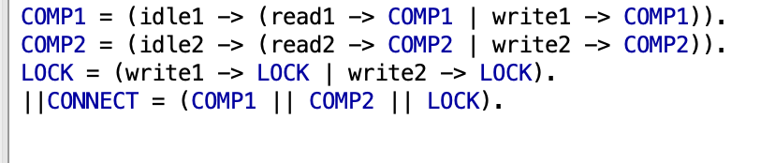9.

10.

12. a)

P0 and S0 are bisimilar as they both allow the actions *a* and *b.*

P1 and S1 are bisimilar as they allow the action *a.*

P2 and S2 are bisimilar as they allow the actions *a*, *b,* and *c*.

P3 and S3 are bisimilar as they allow the actions *a* and *c.*

P4 and S4 are bisimilar as they allow the actions *a* and *b.*

P5 and S5 are bisimilar as they allow the action *c.*

P5 and S6 are bisimilar as they allow the action *c.*

We have proved all states and exhausted all possible cases.

Therefore, P­2 and P3 are bisimilar.

b)

After tracing the string *aa*, P1 would be at either state ­q2 or q3, and P2 would be at state p2. State q2 allows for the actions *a* and *c* to be executed, and state q3 allows for the actions *a* and *b* to be executed. However, state p2 allows for the actions *a*, *b* and *c* to be executed. Thus, q2 and p2 are not bisimilar and q3 and p2 are not bisimilar, therefore making P1 and P2 not bisimilar.

c)

After tracing the string *aa*, P1 would be at either state ­q2 or q3, and P3 would be at state s2. State q2 allows for the actions *a* and *c* to be executed, and state q3 allows for the actions *a* and *b* to be executed. However, state s2 allows for the actions *a*, *b* and *c* to be executed. Thus, q2 and s2 are not bisimilar and q3 and s2 are not bisimilar, therefore making P1 and P3 not bisimilar.

d)

Blue

blue(P1) = aa(c* ∪ b*)ac

blue(P2) = aa(cc*a ∪ a ∪ bb*a)c = aa(c* ∪ b*)ac

blue(P3) = aa((cc*a ∪ a)c ∪ bb*ac) = aa(c* U b*)ac

blue = blue(P1) = blue(P2) = blue(P3) = aa(c* ∪ b*)ac

Pink

pink = pink(P1) = pink(P2) = pink(P3) = bb*ac

cycles = (blue ∪ pink)* -> (from q0 to q0, p0 to p0, s0 to s0)

Traces(P­1) = Traces(P­2) = Traces(P­3) = Pref((blue ∪ pink)*) = Pref((aa(c* ∪ b*)ac ∪ bb*ac)*)